Anthony Bugatto

CS 455: Mobile Sensor Networks

27 March 2018

Project 1: Flocking

**Case 1:**

The first case of the flocking algorithm was without gamma agents and had the characteristic of fragmenting. You can see that the system fragments as expected with outward trajectories from initial positions. The velocities vary depending on how many nodes are causing a potential increase and the connectivity converges to zero. The response is shown in the following figures:

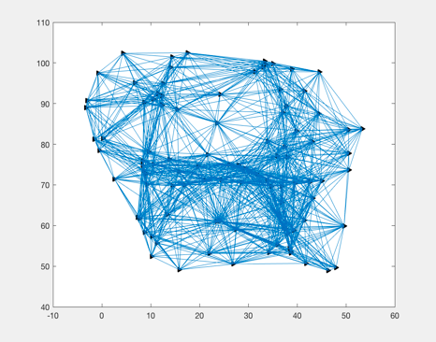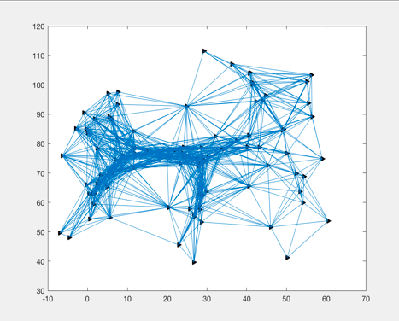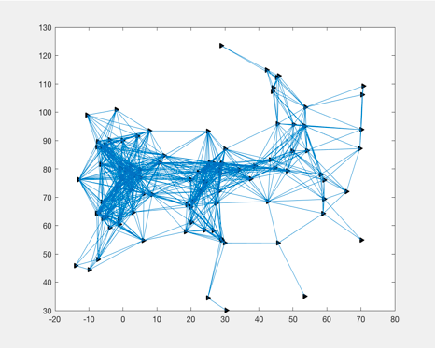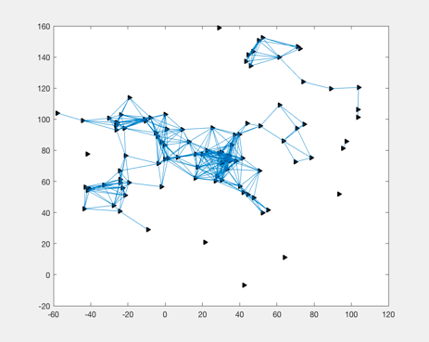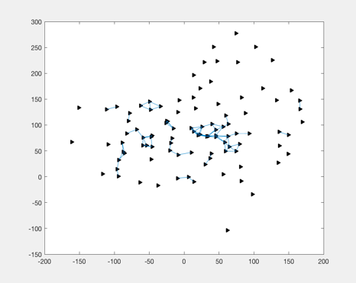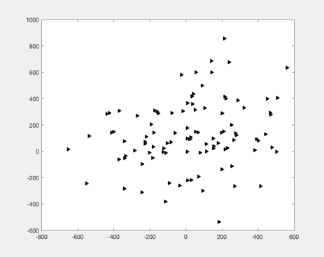

1

2

3

6

4

5

Figure 1.1: (1-6) Show the response if the sensor network as a function of time, very clearly showing the fragmentation

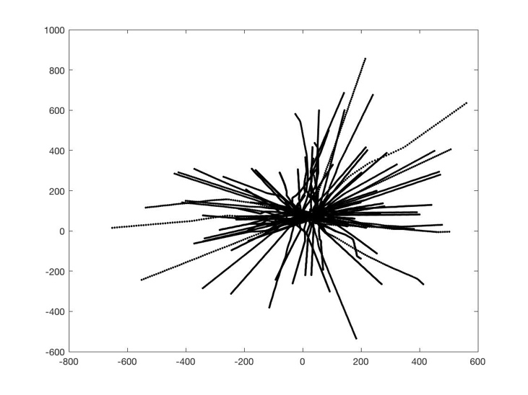

Figure 1.2: The trajectories of the nodes

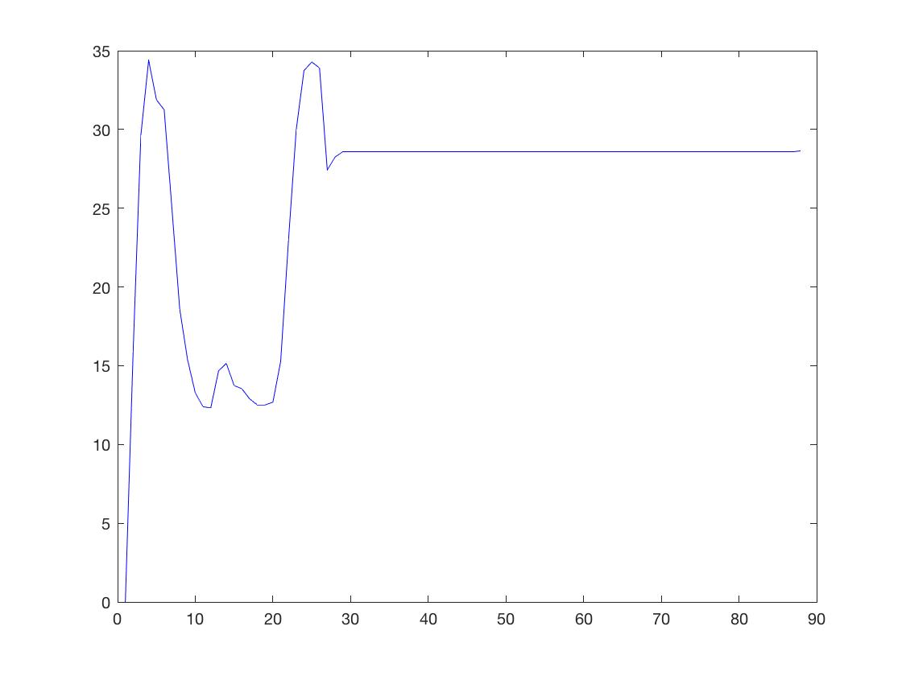

Figure 1.3: Velocities of all the Nodes

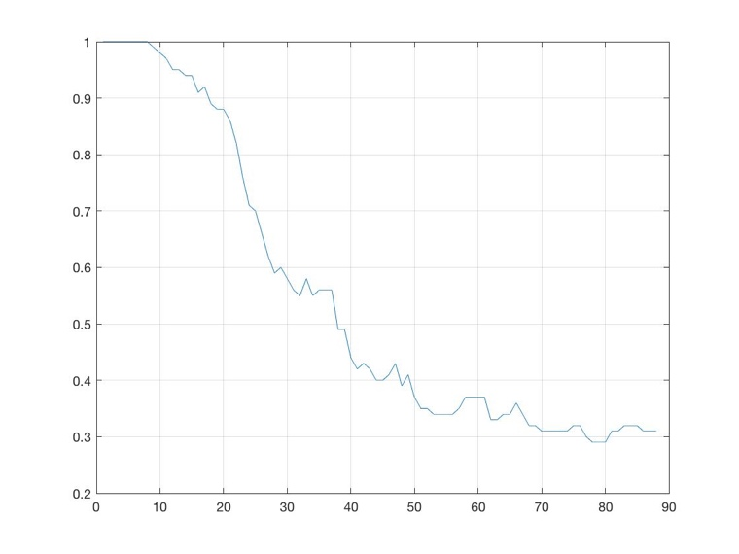

Figure 1.4: Connectivity of Graph

**Case 2:**

The second case differs from the first in that we make a target (gamma agent) and add the extra bit of the Ui(i) control acceleration due to the target. We can see that the connectivity stays the same and the velocity increases before dropping at the target position. We can see some fragmentation as the flock progresses to the target however. Additionally, we can see the position mean trajectory in the simulation. The response is shown in the following figures.

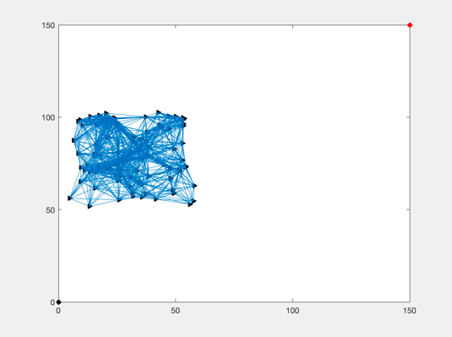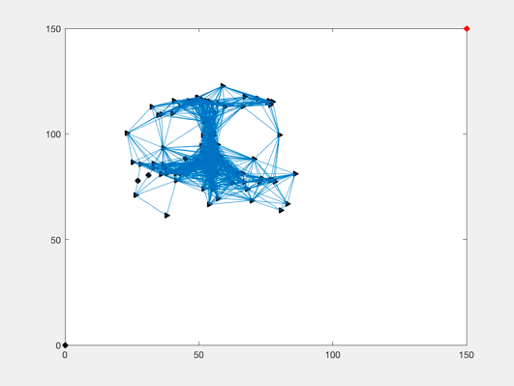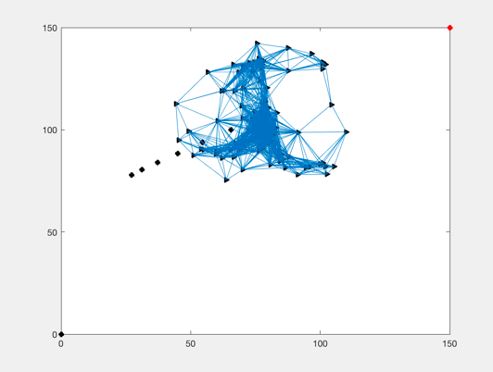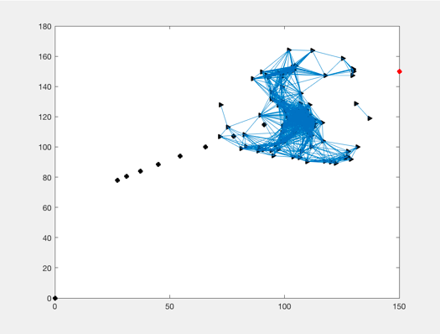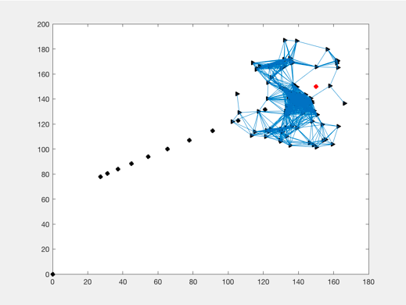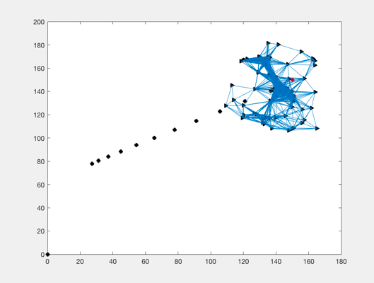

1

2

3

4

5

6

Figure 2.1: The flock moves towards and stops at target (red). We can see the black squares represent the trajectory of the flock at each time step. There is some noticeable fragmentation

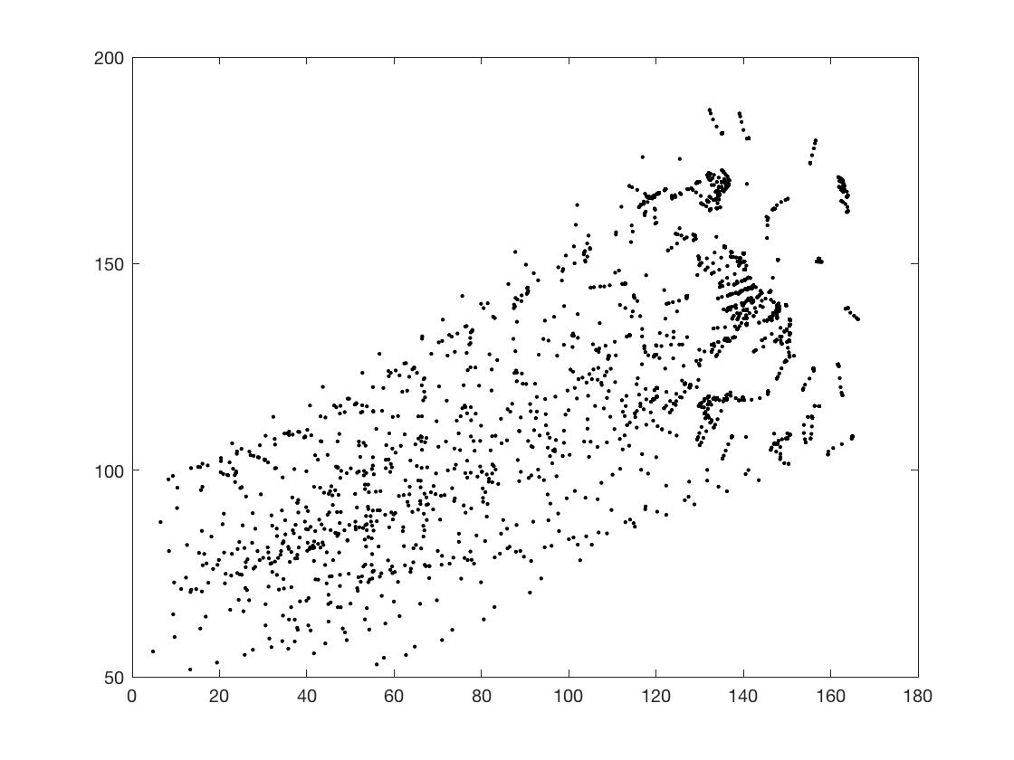

Figure 2.2: The trajectories of the flock

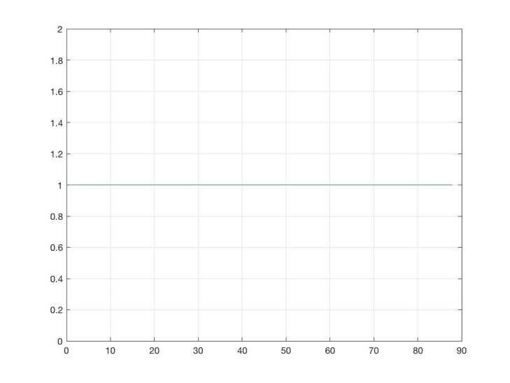

Figure 2.4: The connectivity of the flock (always at 1)

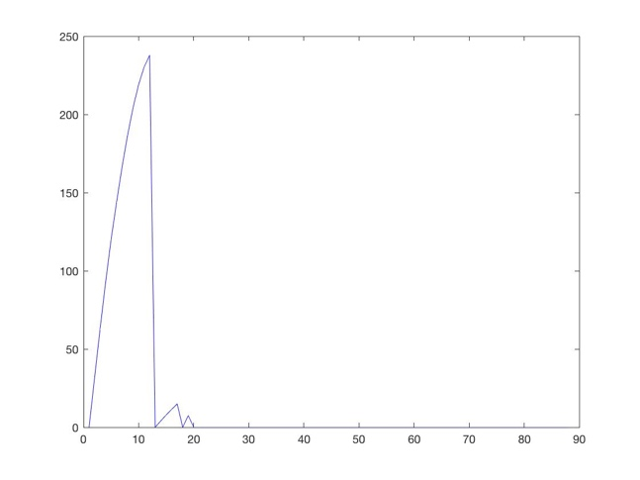

Figure 2.3: The velocities of the flock

**Case 3**

Case 3 produces a much better result than case 2 in that there is no fragmenting and that the target is followed nearly perfectly. As a sine wave target is employed we can see the flock follow very accurately throughout the simulation. The flock trajectory reflects this but shows a small error along the sine wave. We can see that the trajectories all start fragmented and quickly move to follow the sine wave target. The velocities seem to change depending on the target after the initial fragmentation which is interesting and the connectivity starts at zero and quickly moves to one for the duration of the simulation. The response is shown in the following figures:

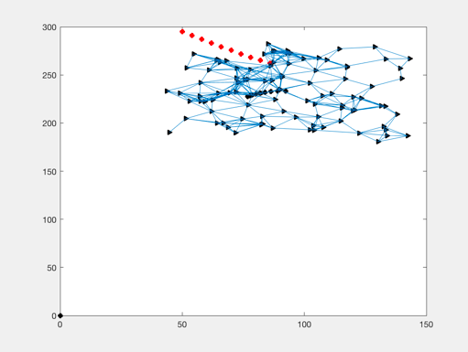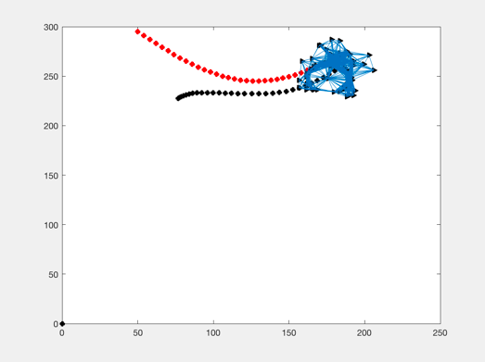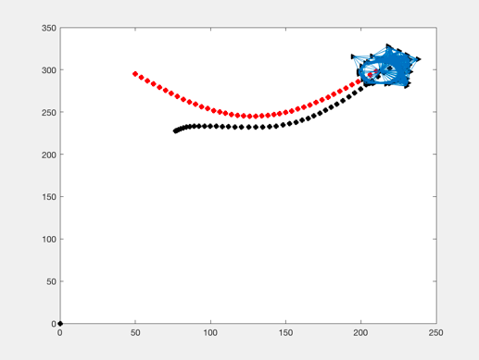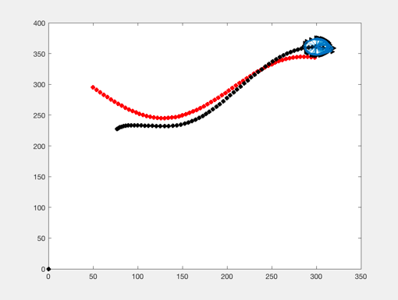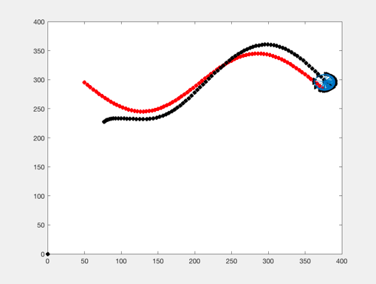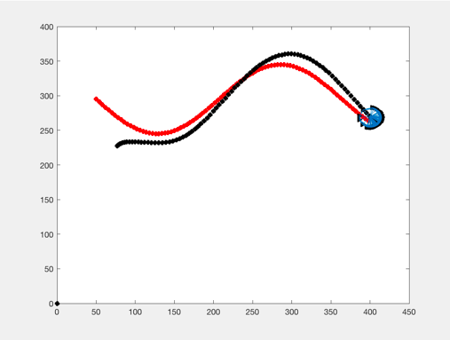

1

3

2

4

5

6

Figure 3.1: The nodes initially comes together from their scattered positions and then begin following a sine wave trajectory (red). The flock trajectory can be seen in black

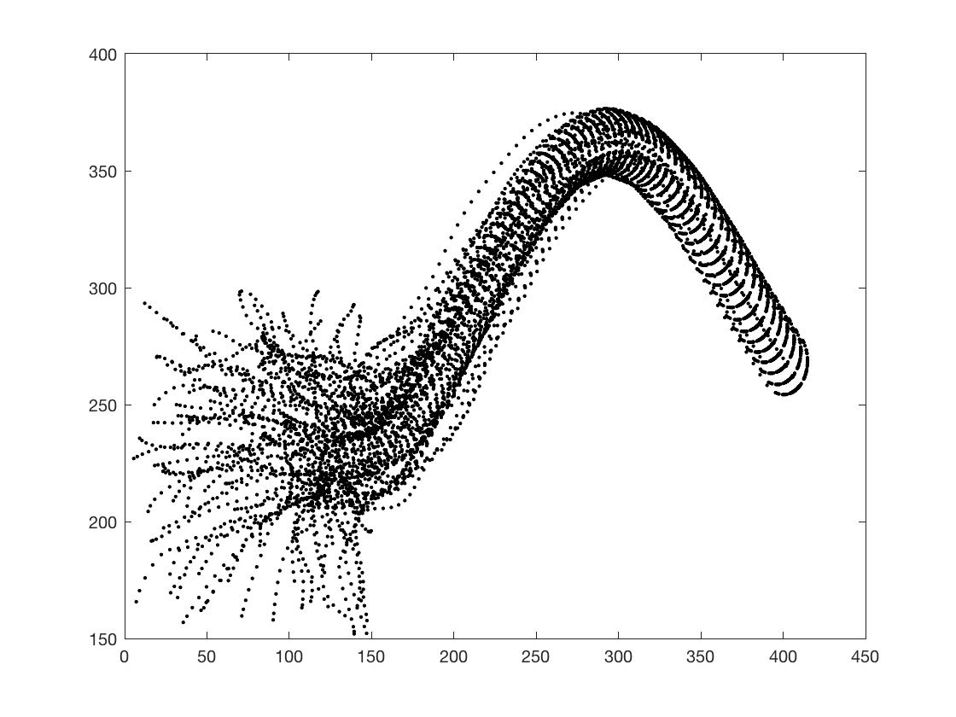

Figure 3.2: The trajectories of the system responding to a sine wave moving target

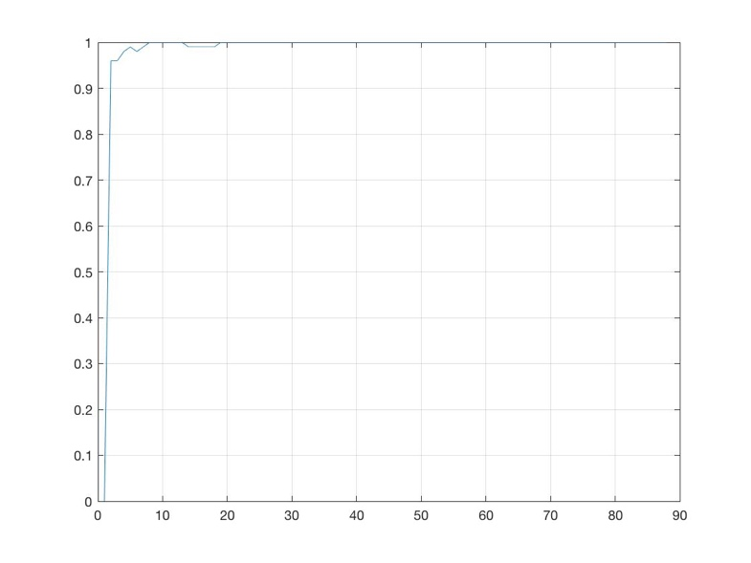

Figure 3.4: The connectivity of the flock

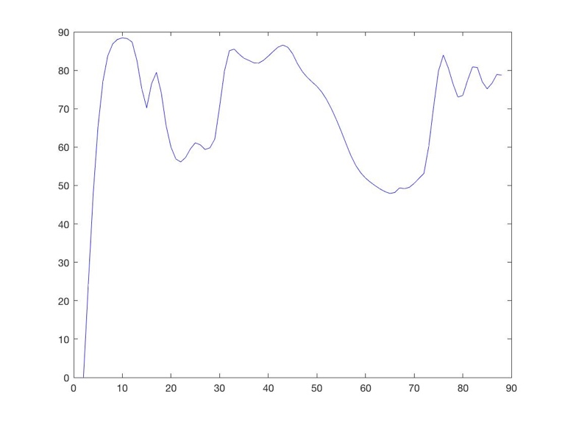

Figure 3.3: The velocities of the flock

**Case 4**

This simulation works identically to the previous one with the difference that it’s tracking a circular target rather than a sine wave. This one is not quite as accurate as the previous but we can see that despite the error, the flock follows the circle fairly accurately. The connectivity stays at one after the defragmentation and the velocities decrease after the fragmentation. The response is shown in the following figures:

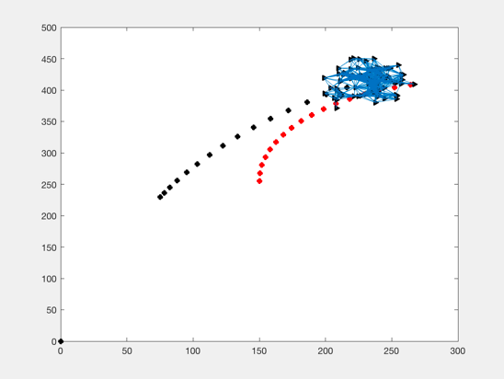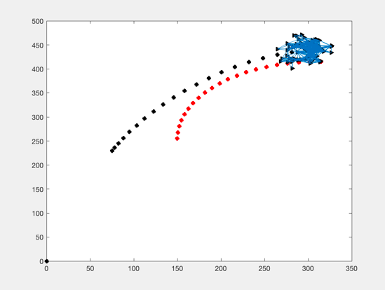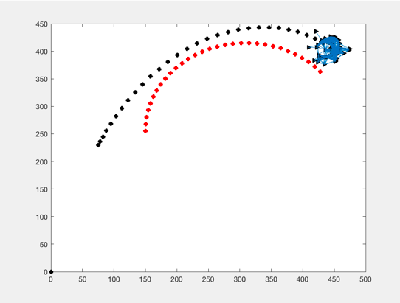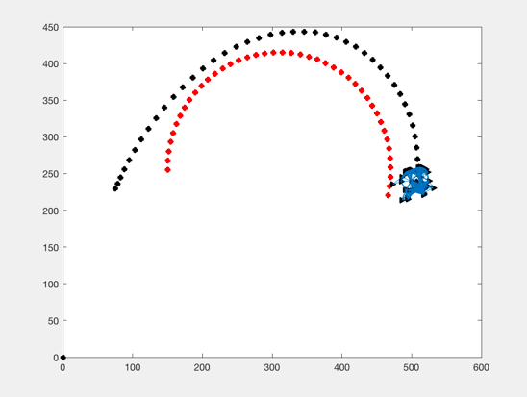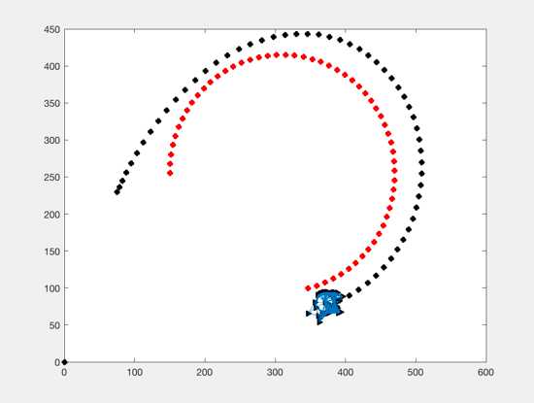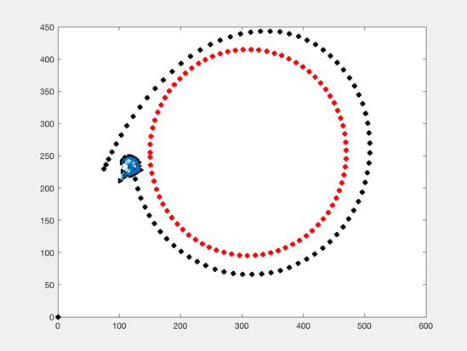

1

6

5

4

3

2

Figure 4.1: The flock following the trajectory of a circle. We can see from the black lines that there is an error in the tracking

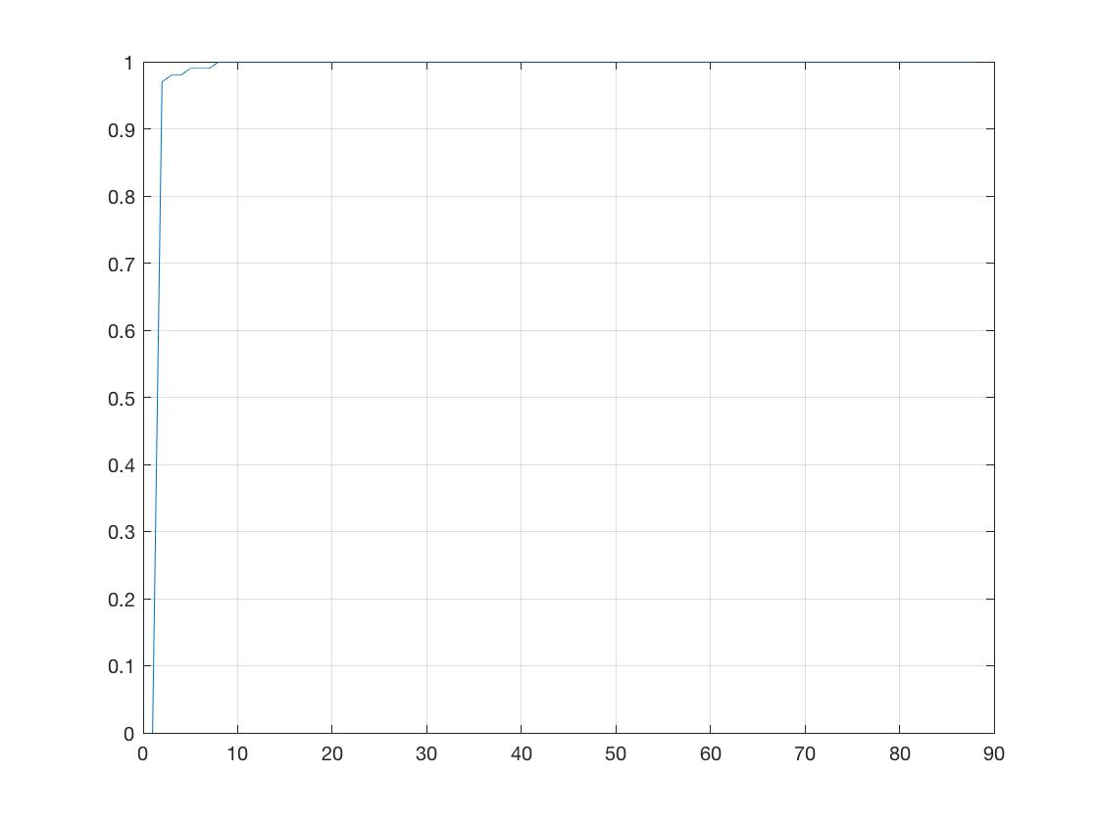

Figure 4.4: The connectivity of the flock

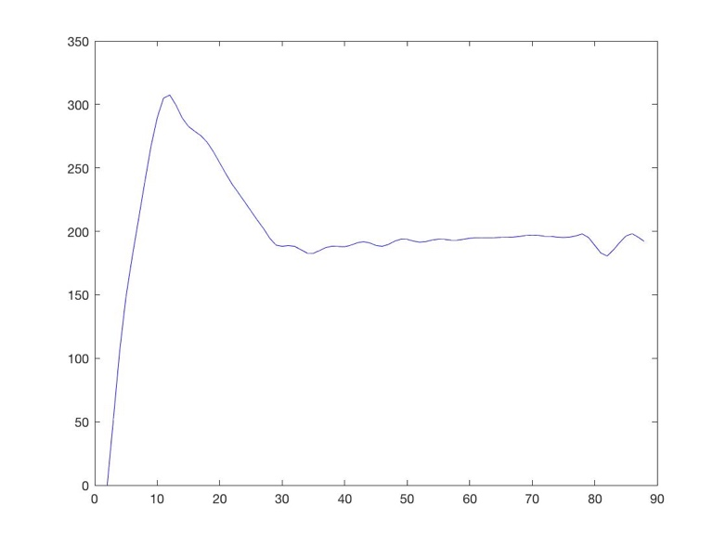

Figure 4.3: The velocities of the nodes

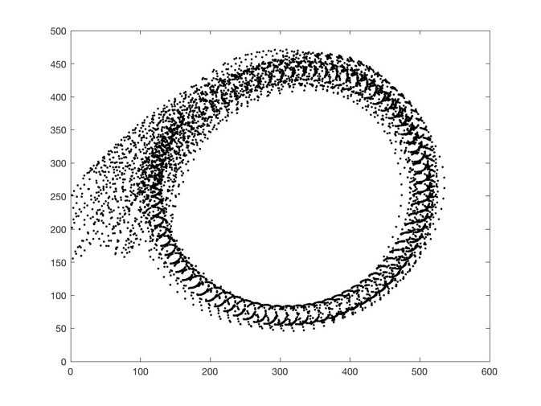

Figure 4.2: The trajectories of the nodes following the circular path of the target